

**GLOBAL FUND PROGRAM MANAGEMENT UNIT**

**COHORT FOUR GROUP A NARRATIVE REPORT FOR AGYW MENTORSHIP PROGRAM**

**Instruction:**

|  |  |
| --- | --- |
| SR Name | GLOBCOM |
| DATE OF SUBMISSION | 1st DECEMBER2020 |
| REPORTED BY | NANCY ANYANGO ODHIAMBO  ANGELINE AKINYI OMWARE |
| COUNTY | SIAYA |
| SUB-COUNTY | ALEGO USONGA |
| WARD | NORTH ALEGO |
| VENUE | MBAGA MIXED PRIMARY SCHOOL AND SDA NORTH CHURCH |
| TARGET GROUP | 19-21 YEARS AGYWs |
| OBJECTIVES | * REDUCE HIV RISK AMONG AGYWS * IMPROVE SEXUAL AND REPRODUCTIVE HEALTH OUTCOME * SUPPORT STRATEGIES ON RETENTION OF ADOLESCENTS IN HIV CARE AND STRENGTHEN ADHERENCE |
| PROGRAM | MY DREAM BEYOND COVID-19 |

**Activity Details**

|  |  |  |  |
| --- | --- | --- | --- |
| Start Date 10/12/2020…………………………………… | | End Date 31/12/2020  ………………………………………. | |
| Number of Mentors | 2 | | |
| Beneficiaries Reached  *(Who Completed All the Sessions)* | Female | | Male |
| C4GA 17 | | C4GA 8 |

Attendance by sessions:

|  |  |  |  |  |
| --- | --- | --- | --- | --- |
| **Session 1** | Date C4GA 10/12/2020 | | | |
| Attendants | Female | C4GA 17 | Male | C4GA 8 |
| **Session 2** | Date C4GA 12/12/2020 | | | |
| Attendants | Female | C4GA 17 | Male | C4GA 8 |
| **Session 3** | Date C4GA 17/12/2020 | | | |
| Attendants | Female | C4GA 17 | Male | C4GA 8 |
| **Session 4** | Date 24/12/2020 | | | |
| Attendants | Female | C4GA 17 | Male | C4GA 8 |
| **Session 5** | Date… C4GA 31/12/2020 | | | |
| Attendants | Female | C4GA 17 | Male | C4GA 8 |

**Introduction**

We first had a virtual training meeting at summit hotel for six consecutive days. We were taken through my dream beyond covid-19 program, its pillars and the basics of mentorship which were to be a guide on how to implement our sessions with the mentees. We were also introduced to the peer books which we were going to use.

**Mobilization**

After a successful meeting and roll out of the program by the organization on 27th November 2020 we were paired and allocated 300 mentees to be enrolled in a mentorship program in north alego.In this cohort we mobilized 75 mentees some from around Mbaga village, Kanungo village, Gombe, Nyakongo, Hono, Uranga and Banana village. We mobilized using school going AGYWs (by then class four and class eight pupils) to pass on information after being permitted by the school administration to do so and a church leader at Kanungo SDA north church who allowed us to pass the information during a church meeting. We also used football coaches at Kanungo village and Mbaga village as most males played football there .The exercise was not easy as most of them preferred playing football to attending our sessions but after proper convincing we managed to complete successfully and we managed to get the required target of participants in this cohort.

**Methodology used**

The following materials were provided;

* Peer books
* Sticky notes
* Flipcharts
* Participants note books and pens
* Mark pens
* Session plan for the five sessions

During the five sessions; group activities, role plays, mini lectures, ice breakers, were used as a facilitation method as guided by the session plans

**Progress:**

**1. C4GA**

**a) Session one**

Introductions, expectations and introduction to sexual and gender based violence was our first session with the mentees which was held at Mbaga mixed primary school on 10TH DECEMBER 2020 as from 2.00pm to 5.30pm by mentors Nancy Anyango Odhiambo and Angeline Akinyi Omware.

The topics discussed were:

* Climate setting and introduction of mentees
* Introduction of my dream beyond covid -19
* Facilitator session (introduction of topic to mentees)
* Group work
* Brief on next session

When introducing the program we realized the mentees were wondering how SGBV and my dream beyond covid-19 were connected, we explained this keenly from the rapid assessment conducted. The mentees were grouped and they did a group assignment and presented in class. As we closed the session we gave them a take home assignment which would be checked during the recap session.

**Session questions**

My mother cannot start a business because my father takes all her money how can I resolve that?

Why that is my father treats me different from any other person in the family?

**b) Session two**

Introduction to sexual and gender based violence in our communities was our second session which was held at Mbaga mixed primary school on 12TH December 2020 as from 2.00pm to 5.30pm by mentors Nancy Anyango Odhiambo and Angeline Akinyi Omware.

**The topics discussed were:**

* Recap of session one
* Facilitator session/group discussion topics and resource mapping activity
* Goal setting pillar: the rubber band activity
* Question and answer session (the questions the mentees dropped in the box during last question)
* Brief of the next session

We discussed all the outlined topics in detail and the mentees were tested by giving them group works which was presented during the session and a take home assignment which would be presented the next week by a representative from each of the five groups. During the goal setting pillar topic the mentees drew a picture of what they wanted to become and shared with their fellow mentees.

**Session questions**

Are my parents responsible for my dreams to come true?

My parents keep saying I am dreaming too big and I can’t even see how my background ,should I listen to them?

**c) Session three**

Rape and post rape medical emergency services was our third session which was held at Mbaga mixed primary school on 17TH December 2020 as from 2.00pm to 5.30pm by mentors Nancy Anyango Odhiambo and Angeline Akinyi Omware.

**The topics discussed were:**

* Recap session and group task activity to compile the peer club vision board
* Facilitator session and group discussion
* Community action pillar: what can you change in your community?
* Questions and answer session (the questions that the mentees dropped in the box during the session
* Brief on next session

Group leaders appointed people who did a recap session after which the outlined topics were well tackled and a take home assignment which would be presented the next week during recap session was given and we ended the session well.

**Session questions**

If someone rapes me and I kind of enjoy the situation does it mean I am abnormal and can I still report the person?

Can a doctor also rape a patient in the hospital and in this situation can action be taken?

**d) Session four**

Sexual reproductive health (SRH) information was our fourth session with the mentees which was held at Mbaga mixed primary school on 24th December 2020 as from 2.00pm to 5.30pm by mentors Nancy Anyango Odhiambo and Angeline Akinyi Omware.

**The topics discussed were:**

* Recap session and group task activities
* Presentations on the discussions questions given in the previous session
* Question and answer session (the questions dropped in the box during last session)
* Brief of the next session
* Implementing community action pillar activity

All of the outlined topics were thourouly tackled and the mentees were tested by giving them group works to do and present in class, a take home assignment which would be presented the next week during recap session was given. During the session the mentees implemented community action by sweeping Mbaga dispensary.

**Session questions**

Why should we not wash our vaginas with soap, wont it smell bad?

Can I have sex when on my periods?

**e) Session five**

Life skills was our fifth and last session with the mentees which was held at Mbaga mixed primary school on 31ST December 2020 as from 2.00pm to 5.30pm by mentors Nancy Anyango Odhiambo and Angeline Akinyi Omware.

**The topics discussed were:**

* Recap session and introduction to life skills
* Facilitator session and group discussion
* Group work presentation recap on goal setting in relation to life skill and character formation
* Question and answer session (the questions that the mentees dropped in the box during the last session and any other questions that they have)
* Winding up session

We requested mentees to appoint someone who would give us a vote of thanks and a brief talk on the experience .During our recap session we appointed one mentee because of time to give us a brief recap of previous session .We completed all the outlined topics in time and we ended as planned with vote of thanks and the brief discussion on the next phase we were implementing as from January after which the mentees dispersed.

**Session questions**

How can I feel good about myself if I dropped out of school and have two children out of wedlock?

Can an expectant girl also attend our sessions?

**Challenges:**

**C4GA**

|  |  |
| --- | --- |
| **CHALLENGES** | **RESOLUTIONS** |
| At first some mentees only thought they were just coming to sign for refreshment allowance as they thought they were too busy to attend sessions | We informed them that we are not just dishing out money to people ,but we are there to create awareness and possibly end SGBV that was going on in the community |
| For the first session most of the mentees did not keep time as required | We had to discuss with them on the appropriate time to start class and told them that the person who came late would be the last to sign which motivated them to come early |

**Lesson Learnt:**

**C4GA**

* We learnt that dealing with ages 19-21 is easy and one simply needs to start on a good note with them
* We learnt that some already knew about SGBV and even had case studies in their communities.
* We also got to learn that some of these mentees had undergone SGBV like sexual harassments and verbal violence and were not speaking as they thought it was a normal ordeal.

**Conclusion and Recommendations:**

**C4GA**

**Conclusion**

We ended all our five sessions well. The fifth session was ended after a discussion on our next phase which was to be held on quarterly basis. As we closed our intensive phase we ended with a vote of thanks and feedback on how sessions had been from a male mentee and a female mentee and a brief talk from each of the mentors (Angeline Akinyi Omware and Nancy Anyango Odhiambo)

**Recommendations**

* From mentor-the mentees should have a demonstration for condom use both male and female as they kept asking questions about the same and they should also be provided with condoms if available
* From mentees-Organization should train peer counsellors everywhere in the village to help pass the information as most of the AGYWs are left out in the sessions.

**Success story**

Dealing with these group at first was quite difficult as they felt they are too old to sit in a class and listens to these mini lectures, most of them felt that they were too busy to be in class and only wanted to register for refreshments but after speaking sense into them they conformed and were willing to attend all our sessions .They praised how well we had taught them session one.

**Session photographs**

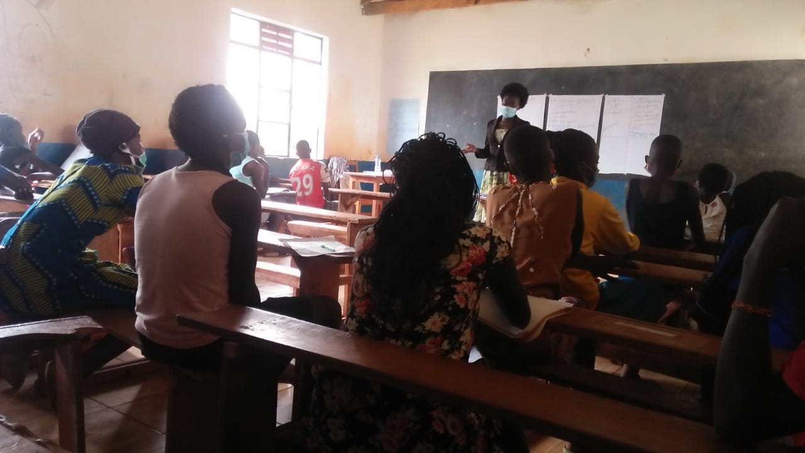

*Mentor Angeline omware conducting session two with C4GA at Mbaga mixed primary school on 12th December 2020*

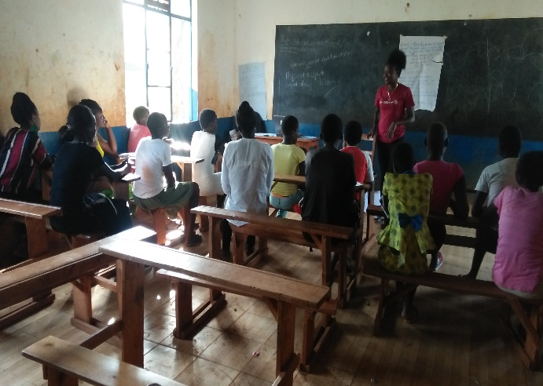*Mentor Angeline giving brief last talk after mentor Nancy during the last session at Mbaga mixed primary school on 31st December 2020*

***Name and Signature of Person compiling the Report***

|  |  |
| --- | --- |
| NANCY ANYANGO ODHIAMBO | 1ST DECEMBER 2020 |

***Name and Signature of Person approving the Report***

|  |  |
| --- | --- |
| BENSON OKOME | 1ST DECEMBER 2020 |